TC-CMS-005
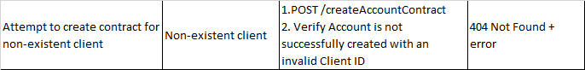
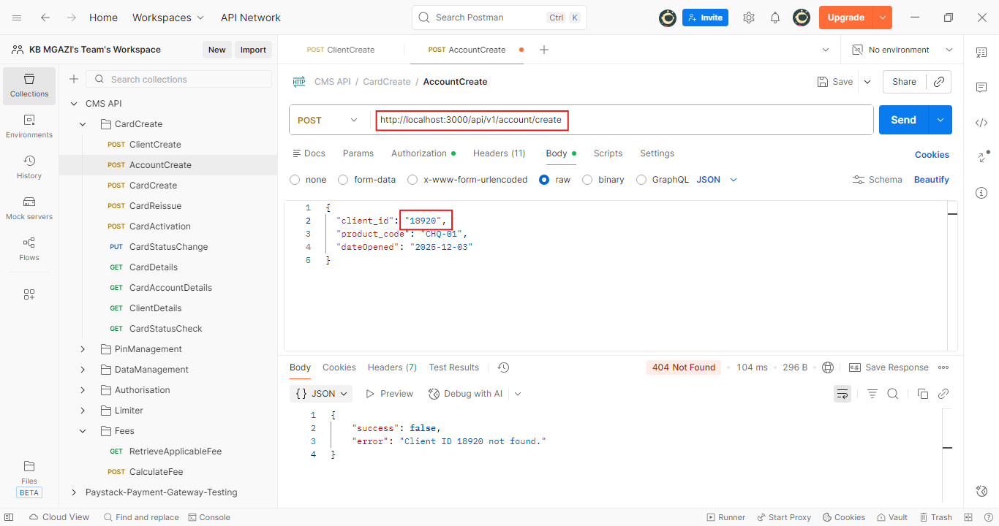
Request:
{
"client_id": "18920",
"product_code": "CHQ-01",
"dateOpened": "2025-12-03"
}

Response:
{
"success": false,
"error": "Client ID 18920 not found."
}

